Day 4 Notes:

TECHZAROS

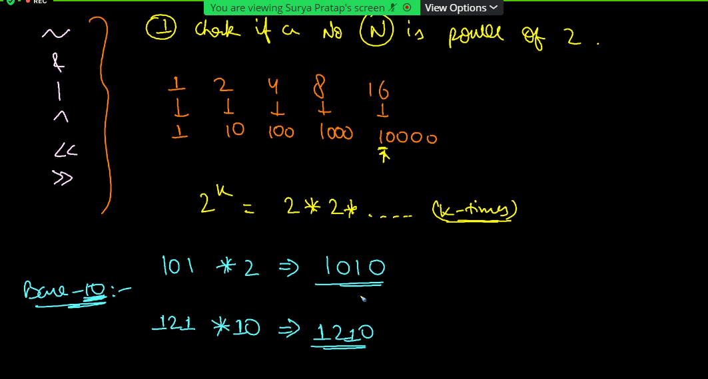

Left shift happens with multiplying with 2

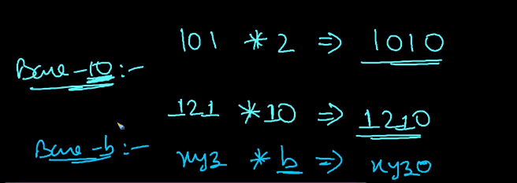

Appending the 0 is done by Base 10 system.

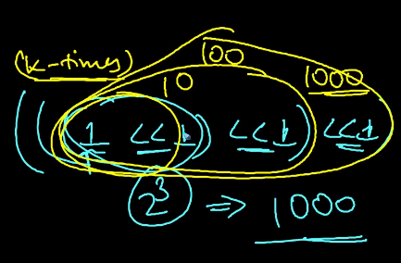 

Let us take if(n&1)==0 this condition gives the exponentials of 2.

All the non significant bit is zero

For Example:

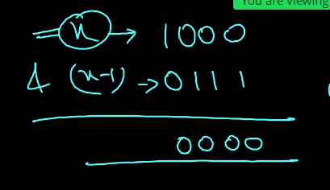

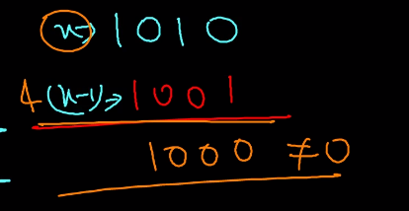

2. Count number of 1s in the binary representation in N;

Let us take n=17;

Count=0;

If (n&1==1) check whether the n is only 1.

Count++;

Count will give the number of 1’s in the binary representation.

T.C = Log n

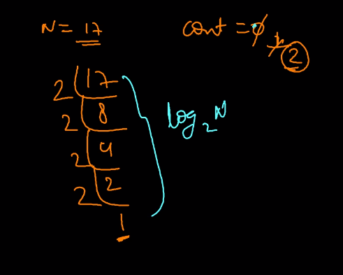

3. Check if the ith bit is a set?

Set means 1

Unset means 0

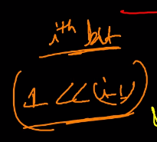

It will create the mask ( The second representation to check whether it is a set.

For Unset Condition: if(N&(1<<(i-1))==0)

4. To Generate all possible subset of the set.

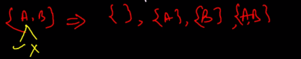

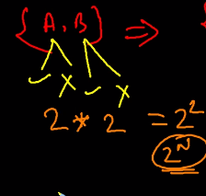

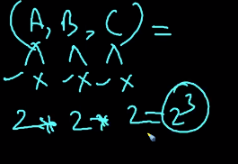

Using this method we can find the number of subset.

We can use Recursion to do that.

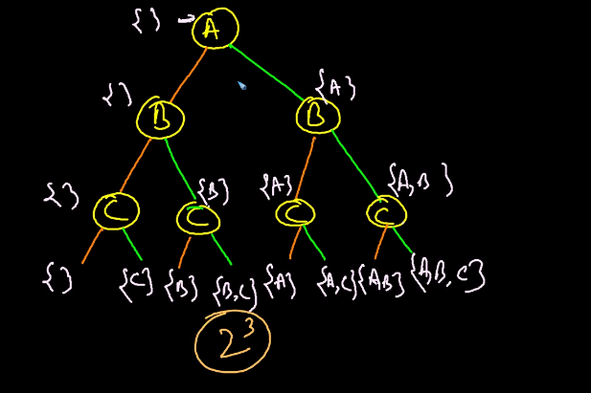

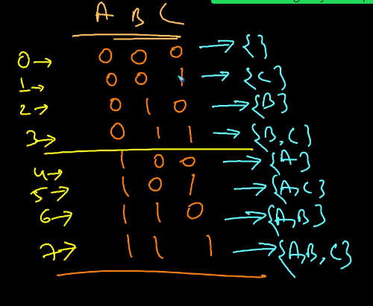

Code represenrtation:

for(i=0;i<2^n;i++)

for(j=0;j<n;j++)

if(i&(1<<j)==1) to check whether it is set.

Print(arr[j]);

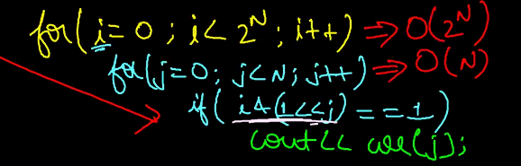

5. Find the largest power of 2 which is less than equal to given number n.

To generate the sequence of 10000 -> 1<<(5-1) which gives the 5 place as 1.

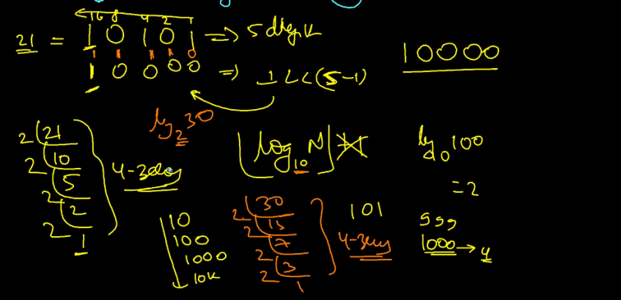

6. Find the right most 1 in binary representation

Keep on creating the mask it reaches the set.

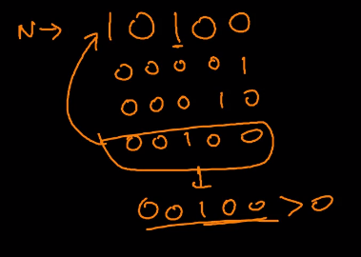

Binary representation subtraction follows same subtraction formula as decimal.

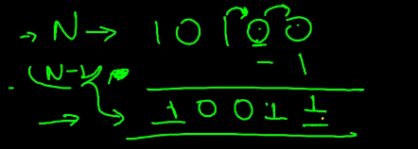

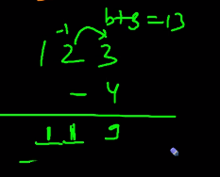

It also works. But the above is recommended.

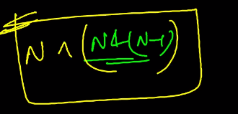

Important Questions:

Compute XOR 1 to n;

Constraint does not exceed 10^8.

Code:

int ans=0;

for(int i=1;i<=n;i++)

ans^=i;

But the above code is not applicable for 10^8 < 10^9

**Expectation with the constraint**

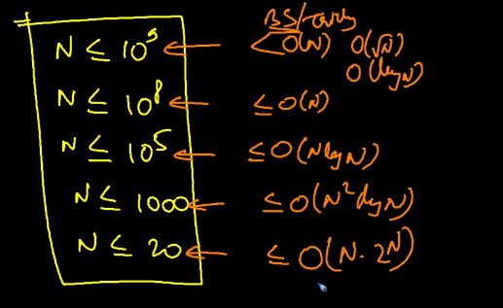

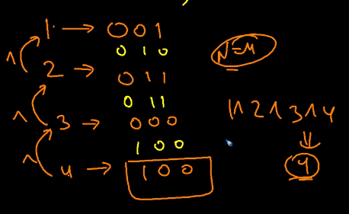

For the testcase above 10^9

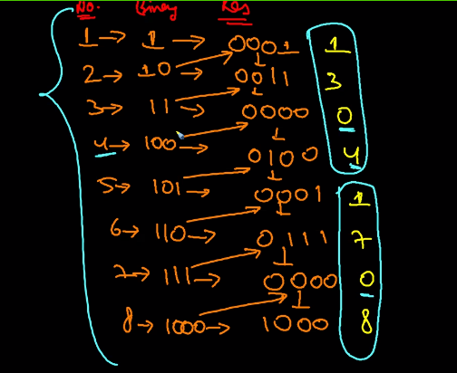

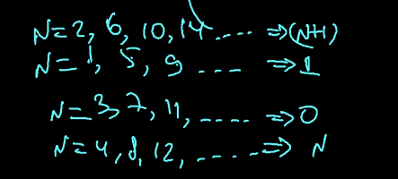

Logic in Code:

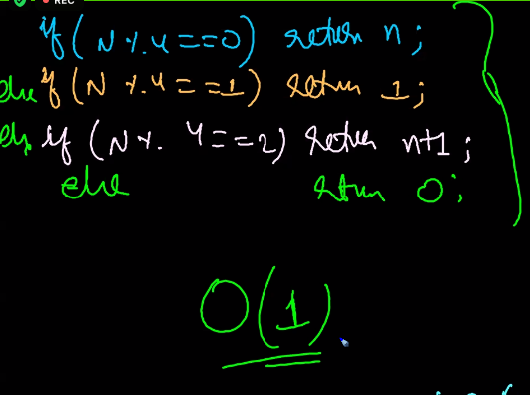

6. Fastest way to swap 2 numbers?

a^=b;

b^=a;

a^=b;

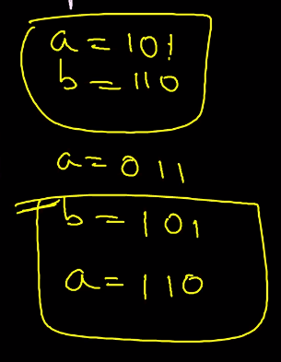

7. Flip all the bits of n:

N=1011

0100 -> ( 1011 needs to be changed to this representation) how will we do that!

We can achieve this by Taking Xor for all representation with 1.

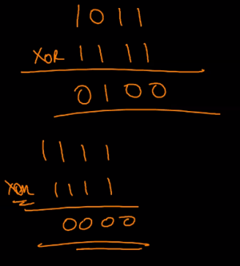

To generate the 1’s (2^d-1).

9. Lower case to upper case using Bit manipulation

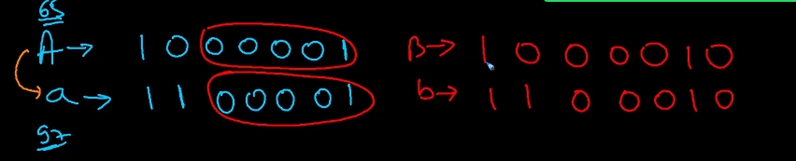

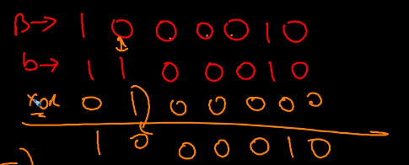

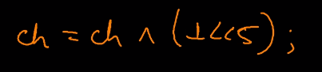

10. Count of set bit; __builtIn_popout(num);

11. Count leading 0’s -> __builtIn+clz(num); **(check again in Internet)**